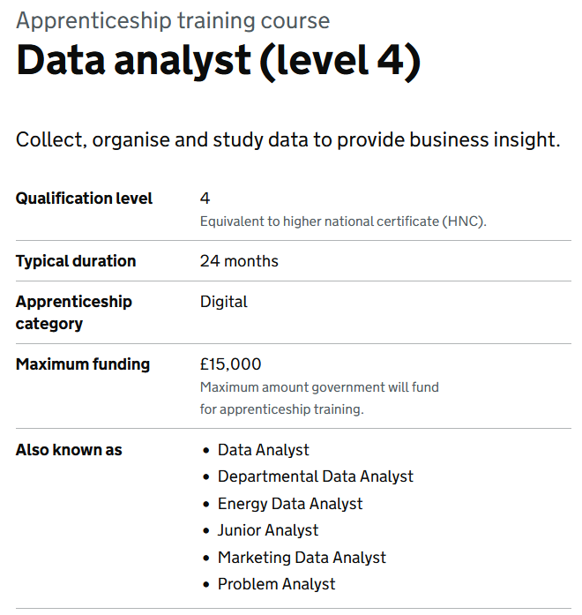



What happens at the end of the apprenticeship?
You may be offered permanent employment at the end of the apprenticeship period. You can also search for job vacancies on the NHS Jobs website (www.jobs.nhs.uk). Some apprenticeships also allow you to gain UCAS points and can lead onto a university course. You should always check with the organisation that provides your apprenticeship for details.

What if I don't feel ready for an apprenticeship?
If you are not quite ready for an apprenticeship, a traineeship might be for you. A traineeship is designed for young people who want to get a job and the skills and experience to boost their career prospects. It will provide up to 6 months of work experience, work preparation training, and English and maths support (if needed) to secure an apprenticeship or other employment.
- Use data systems securely to meet requirements, principles of Privacy by Design

- implement the stages of the data analysis lifecycle.

- apply principles of data classification within data analysis activity

- analyse data sets taking account of different data structures and database designs.

- assess the impact on user experience and domain context on data analysis activity.

- identify and escalate quality risks with suggested mitigation or resolutions as appropriate.

- undertake customer requirements analysis and implement findings in planning & outputs.

- identify data sources & the risks and challenges within data analysis activity.

- apply organizational architecture requirements to data analysis activities.

- apply statistical methodologies to data analysis tasks.

- apply predictive analytics in the collation and use of data.

- collaborate and communicate with a range of internal and external stakeholders using appropriate styles and behaviours to suit the audience.

- use a range of analytical techniques such as data mining, time series forecasting and modelling techniques to identify and predict trends and patterns in data.

- collate and interpret qualitative and quantitative data and convert into infographics, reports, tables, dashboards and graphs.

- select and apply the most appropriate data tools to achieve the optimum outcome.

There are four levels of apprenticeships available:

1. Intermediate level apprenticeships
Intermediate level apprentices follow work-based learning towards level 2 - equivalent to 5 GCSEs at grades 9-4 (A*-C). These apprenticeships provide the skills you need for your chosen career and allow entry to an advanced level apprenticeship.

2. Advanced level apprenticeships
Advanced level apprentices follow work-based learning towards level 3 - equivalent to 2 A-levels. To start this level of apprenticeship, you should ideally have five GCSEs (grade 4 / C or above) or have completed an intermediate level apprenticeship.

3. Higher level apprenticeships
Higher level apprentices follow work-based learning towards levels 4,5,6 and 7 - equivalent to a foundation degree and above. To start this level of apprenticeship, you should ideally have 2 A-levels (or equivalent) or have completed an advanced level apprenticeship.

4. Degree level apprenticeships
Degree level apprentices follow work-based learning towards levels 6 and 7 - equivalent to a full bachelor's or master's degree.
Apprenticeships
Apprenticeships provide routes into a variety of careers in the NHS and are an excellent opportunity to earn, gain work experience and achieve nationally recognised qualifications at the same time.
What is available?
Apprenticeships are offered by individual NHS employers (such as trusts) as well as other non-NHS employers and organisations in many different areas of work. Below are some examples of apprenticeships that are relevant to the NHS.

